3. SEQUENCE OPERATIONS AND SIGNAL ANALYSIS

Objectives:
This experiment is divided into four simulations:
1. Addition and Multiplication of Two Sequences
2. Energy and Power Calculation of Given Signals
3. Autocorrelation
4. Cross Correlation
Experiment 3.1
Addition and Multiplication of Two Sequences
Program:
% Addition and Multiplication of Two Sequences
clc;
clear;
close all;
% Sample index
n = 0:10;
% Sequence 1
x1 = [1 2 3 4 5 6 7 8 9 10 11];
% Sequence 2
x2 = [11 10 9 8 7 6 5 4 3 2 1];
% Addition of sequences
y_add = x1 + x2;
% Multiplication of sequences
y_mul = x1 .* x2;
% Plotting
figure;
subplot(2,2,1);
stem(n,x1,'filled');
grid on;
title('Sequence x_1(n)');
xlabel('n');
ylabel('Amplitude');
subplot(2,2,2);
stem(n,x2,'filled');
grid on;
title('Sequence x_2(n)');
xlabel('n');
ylabel('Amplitude');
subplot(2,2,3);
stem(n,y_add,'filled');
grid on;
title('Addition: x_1(n) + x_2(n)');
xlabel('n');
ylabel('Amplitude');
subplot(2,2,4);
stem(n,y_mul,'filled');
grid on;
title('Multiplication: x_1(n) * x_2(n)');
xlabel('n');
ylabel('Amplitude');
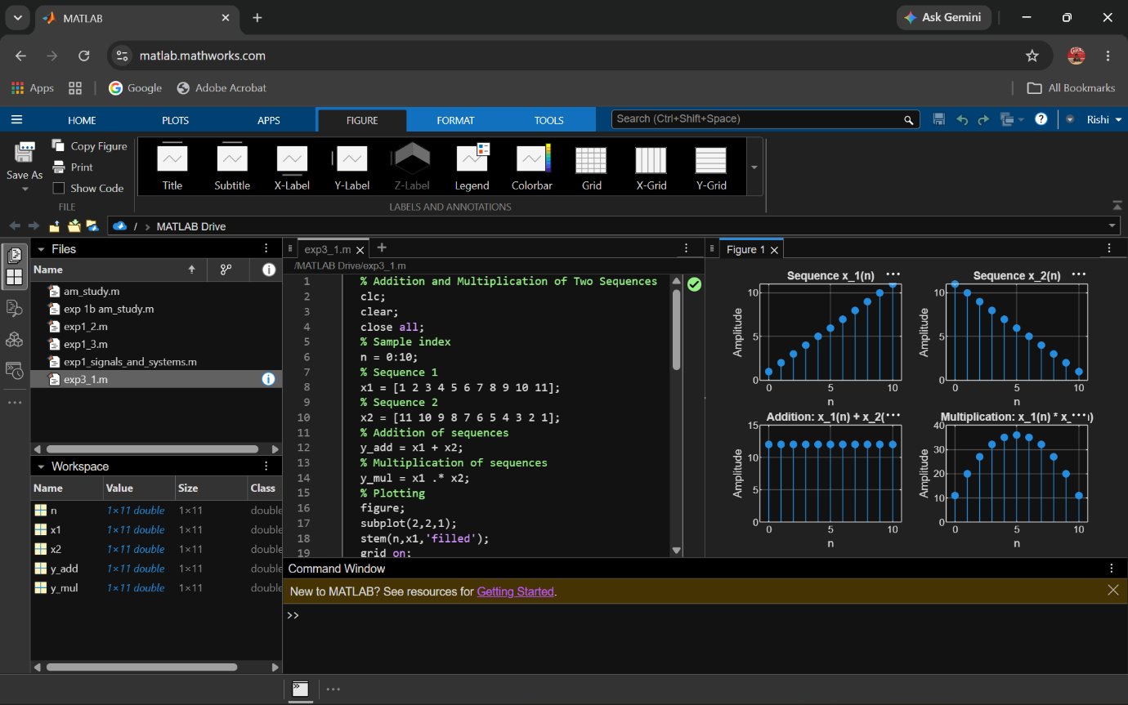
Output:
Experiment 3.2
Energy and Power Calculation of Given Signals
Program:
% Energy and Power Calculation of Signals
clc;
clear;
close all;
% Time index
n = -10:10;
% Signal
x = [zeros(1,10) 1 2 3 4 5 4 3 2 1 zeros(1,10)];
% Energy Calculation
E = sum(abs(x).^2);
% Power Calculation
P = E/length(x);
% Display Results
disp(['Energy of the signal = ', num2str(E)]);
disp(['Power of the signal = ', num2str(P)]);
% Plot Signal
figure;
stem(n,x,'filled');
grid on;
title('Discrete-Time Signal');
xlabel('n');
ylabel('Amplitude');
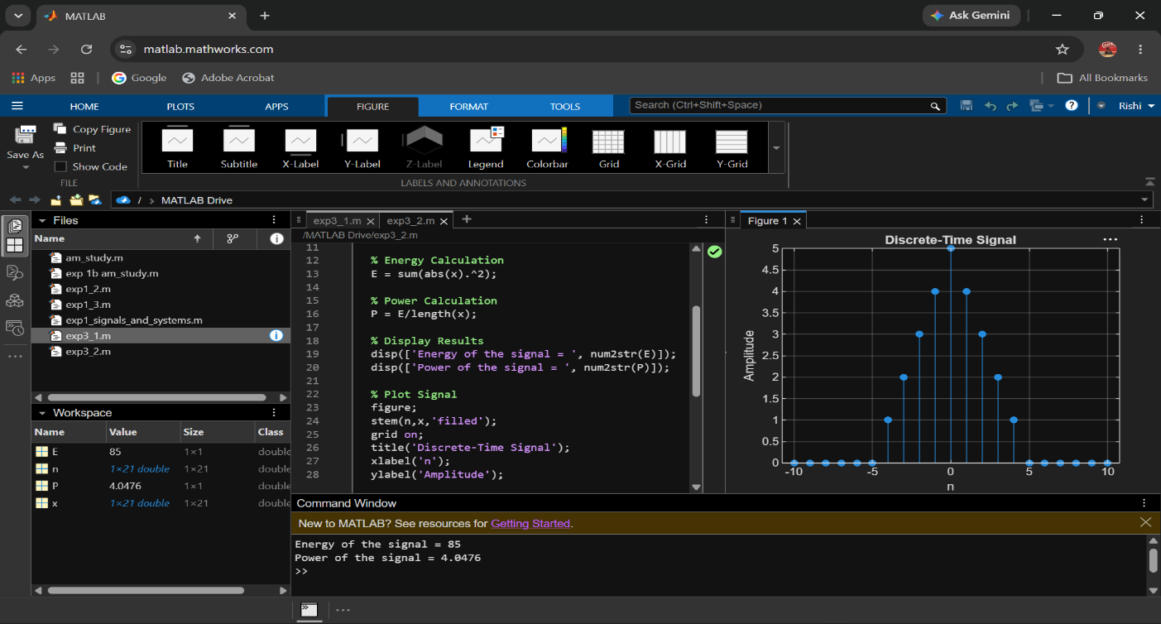
Output:

4. SYSTEM ANALYSIS AND CLASSIFICATION

Objective
This experiment is divided into four simulations:
1. Discrete-Time System
2. Causal/Non-Causal System
3. Analysis of Discrete System
4. Analysis of Continuous-Time System
Experiment 4.1
Discrete -Time System

Program:
% Discrete-Time System
clc;
clear;
close all;
% Input sequence
n = 0:10;
x = [1 2 3 4 5 6 7 8 9 10 11];
% Discrete-Time System
y = filter([1 1],1,x);

% Display output
disp('Output Sequence:');
disp(y);
% Plotting
figure;
subplot(2,1,1);
stem(n,x,'filled');
grid on;
title('Input Sequence x(n)');
xlabel('n');
ylabel('Amplitude');
subplot(2,1,2);
stem(n,y,'filled');
grid on;
title('Output Sequence y(n)=x(n)+x(n-1)');
xlabel('n');
ylabel('Amplitude');

Output:
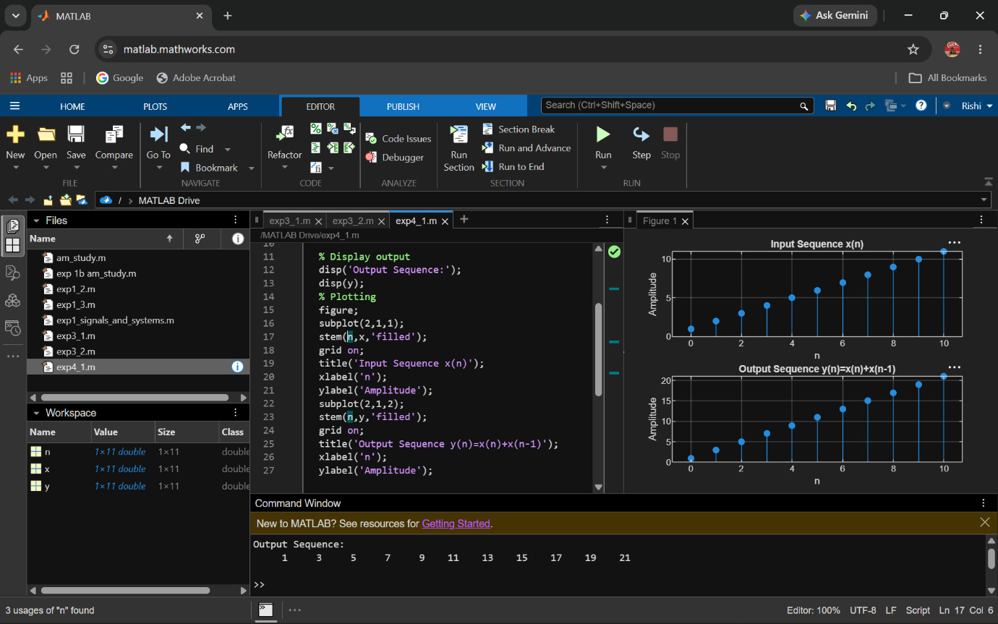

Experiment 4.2
Causal/Non-Causal System
Program:
% Causal and Non-Causal Systems
clc;
clear;
close all;
% Input sequence
n = 0:10;
x = [1 2 3 4 5 6 7 8 9 10 11];
% Causal System: y(n)=x(n)+x(n-1)
y_causal = filter([1 1],1,x);
% Non-Causal System: y(n)=x(n)+x(n+1)
y_noncausal = x + [x(2:end) 0];
% Plotting
figure;
subplot(3,1,1);
stem(n,x,'filled');
grid on;
title('Input Sequence x(n)');
xlabel('n');
ylabel('Amplitude');
subplot(3,1,2);
stem(n,y_causal,'filled');
grid on;
title('Causal System Output y(n)=x(n)+x(n-1)');
xlabel('n');
ylabel('Amplitude');
subplot(3,1,3);
stem(n,y_noncausal,'filled');
grid on;
title('Non-Causal System Output y(n)=x(n)+x(n+1)');
xlabel('n');
ylabel('Amplitude');
Output:
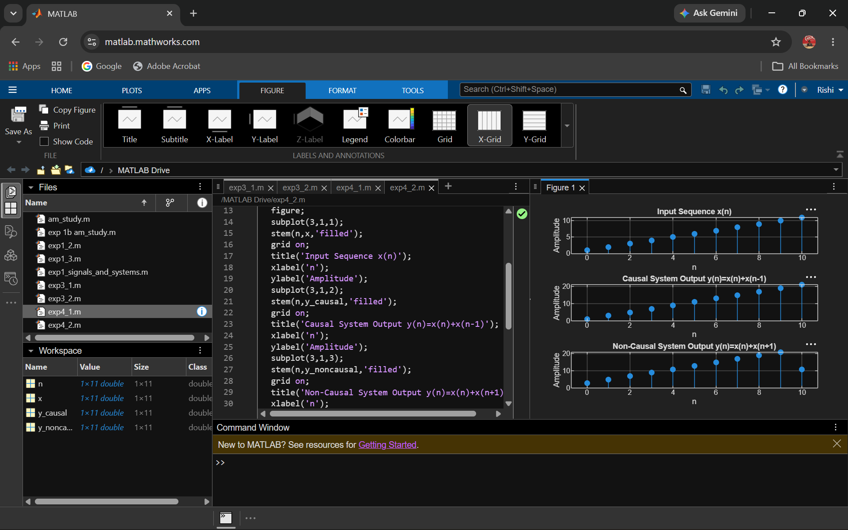

5. System Response and LTI Properties

Objective
This experiment is divided into four simulations:
1.Impulse Response of the System
2. Step Response of the System
3. Verification of Linearity Property of LTI Systems
4. Analysis of Discrete-Time System
Experiment 5.1
Impulse Response of the System
Program:
% Impulse Response of the System
clc;
clear;
close all;
% Sample index
n = 0:10;
% Unit impulse input
x = [1 zeros(1,10)];
% System: y(n)=x(n)+0.5x(n-1)
b = [1 0.5];
a = [1];
% Impulse response
h = filter(b,a,x);
% Display result
disp('Impulse Response h(n):');
disp(h);
% Plot
figure;
stem(n,h,'filled');
grid on;
title('Impulse Response of the System');
xlabel('n');
ylabel('h(n)');
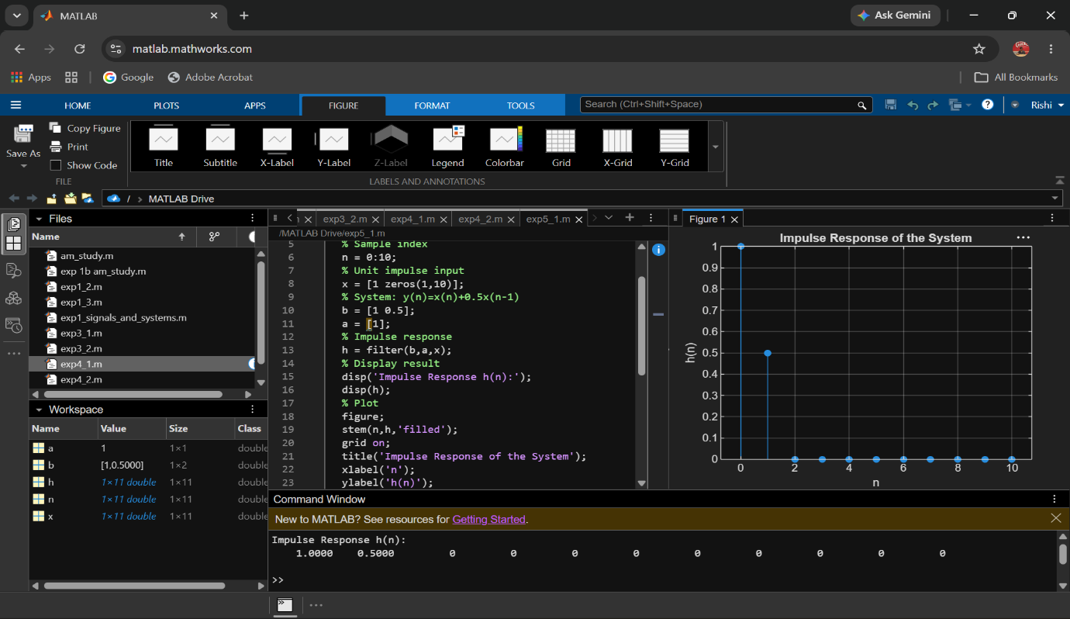
Output:

Experiment 5.2
Step Response of the System
Program:
% Step Response of the System
clc;
clear;
close all;
% Sample index
n = 0:10;
% Unit step input
x = ones(1,length(n));
% System: y(n)=x(n)+0.5x(n-1)
b = [1 0.5];
a = [1];
% Step response
y = filter(b,a,x);
% Display result
disp('Step Response y(n):');
disp(y);
% Plot
figure;
subplot(2,1,1);
stem(n,x,'filled');
grid on;
title('Unit Step Input u(n)');
xlabel('n');
ylabel('Amplitude');
subplot(2,1,2);
stem(n,y,'filled');
grid on;
title('Step Response of the System');
xlabel('n');
ylabel('y(n)');
Output Waveform:
